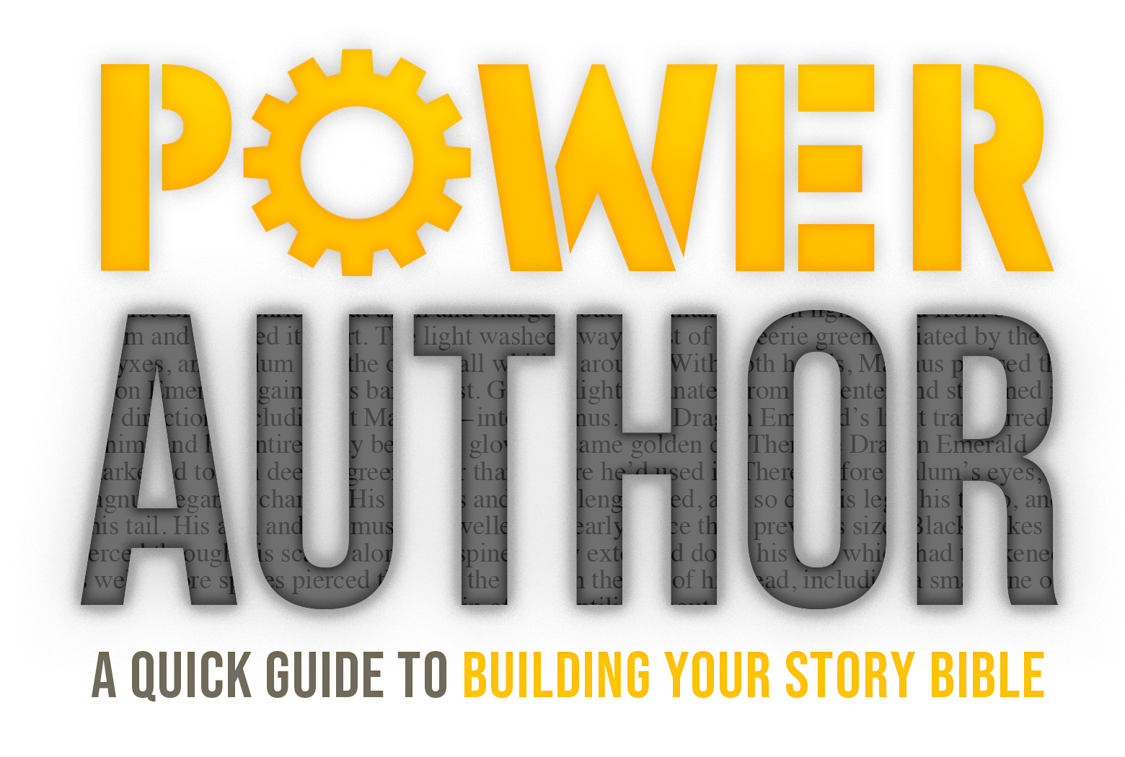

Basic 3-Act Outline for Novels
For examples, refer to Power Author: A Quick Guide to Building Your Story World by Ben Wolf

Backstory: (Add in these details later.)

Act I
Prologue: (optional; shares a part of the story that will come into play later on in the plot.)
Inciting Incident – This is the event that sets your story in motion. Usually in the first chapter.

First Disaster/Door of No Return (DNR) – This is the event that sets your character on a path that will irreversibly change their life forever. Once the character makes this choice/walks through this “door,” they cannot go back to the way things were. The entire story shifts, along with the character’s perspective, once the choice is made. This moment also marks the end of Act I and the beginning of Act II.
Act II
Second DNR – This is the second event that forces your character to make another choice that will irreversibly change their life forever. Once the character makes this choice/walks through this “door,” they cannot go back to the way things were. The entire story shifts, along with the character’s perspective, once the choice is made. This moment should occur at the exact midpoint of your novel if possible, right in the middle of Act II.

Third DNR – This is the final event that inspires your character’s final, most crucial choice in the story: will they take the risk and face the challenge head-on, or will they resign themselves to failure? This choice must always plunge your character into the climax which takes place in Act III. Once the character makes this choice/walks through this “door,” they cannot go back to the way things were. The entire story shifts, along with the character’s perspective, once the choice is made. This moment also marks the end of Act II and the beginning of Act III.
Act III

Climax – The story’s central conflict culminates into one final moment where a final choice (or several) is made. This can be a battle, an encounter, an event, a conversation, or any number of other happenings. It is the moment of the highest tension in the story.

Grey Moment – This is the moment when everything looks incredibly bleak for your protagonist, and it is unlikely they will succeed in meeting/achieving their personal story goal(s).
Black Moment – This is the moment when everything looks inescapably bleak for your protagonist, and it is virtually impossible that they will succeed in meeting/achieving their personal story goal(s). The protagonist is merely seconds away from failure or has, perhaps, already failed.

The Turnaround – Something happens that shifts the story again, and it enables the character to find a new solution to the story problem. This can be the interference of another character, a new piece of information, a weapon, a freak happening or moment of good luck, a twist, or anything else that has the capacity to affect significant change to the situation in the climax. (This plot aspect is optional in some story types; if the protagonist will succeed and overcome and win, then it is necessary. If the protagonist loses or fails, it is not necessary.)

Denouement/Resolution – The protagonist has overcome the challenge presented in the climax (or not), and the story moves toward its logical conclusion.

Falling Action – Tie up any and all loose story threads.

